McMaster University

Dept. of Electrical and Computer Engineering

COMP ENG 4TL4 - Term I (Fall) 2023

# **Lab 4 - FIR Filter Design and Analysis**

**Demo Date: Nov. 13**

**Due Date: Nov. 26**

**Tianze zhang 400208135**

**Xiang li 400197429**

# [**zhant22@mcmaster.ca**](mailto:zhant22@mcmaster.ca)

# [**lix289@mcmaster.ca**](mailto:lix289@mcmaster.ca)

**Q1: The truncation method of FIR design**

Plot from matlab:

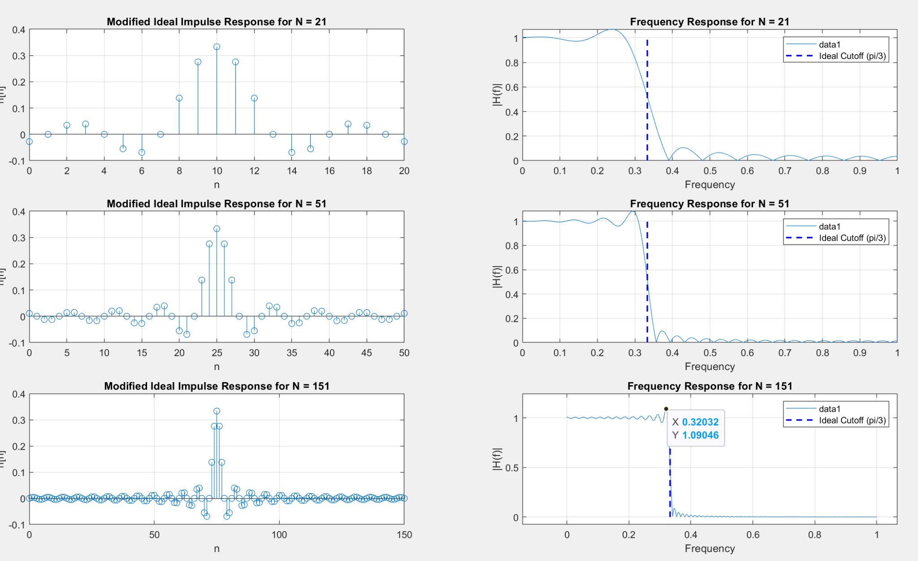

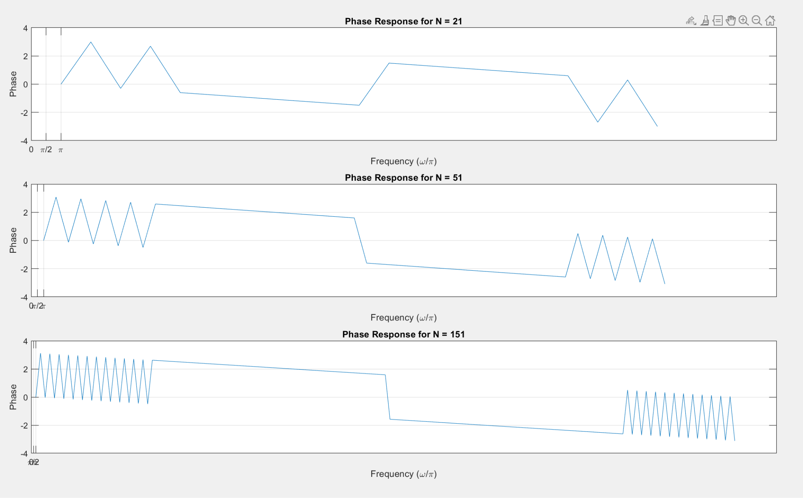

(b):As we can see even though we increase the N value, we can still see that the max amplitude of each N is above 1 all the way to around 0.09. So this is the Gibbs phenomenon.

C: As we can see from the phase plots of each M, the slope is a linear line which means the filter has a linear phase.

D:

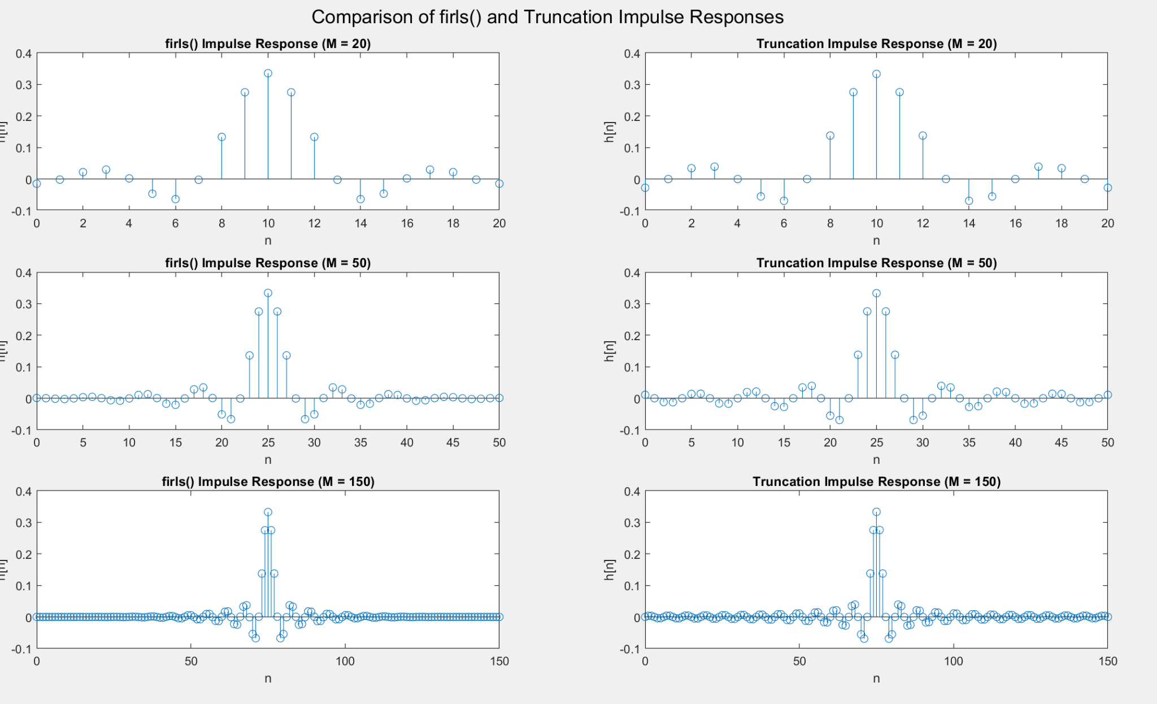

As we can see the impulse response is identical.

E:

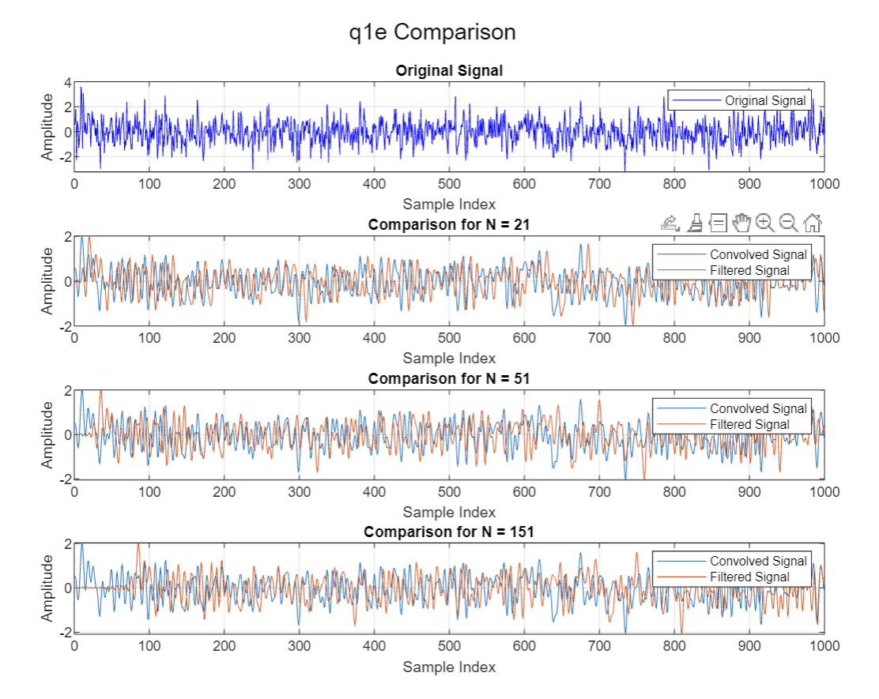

As we can see, the filter of both methods is doing similar filtering.

**Q2:The Parks-McClellan optimization method of FIR design**

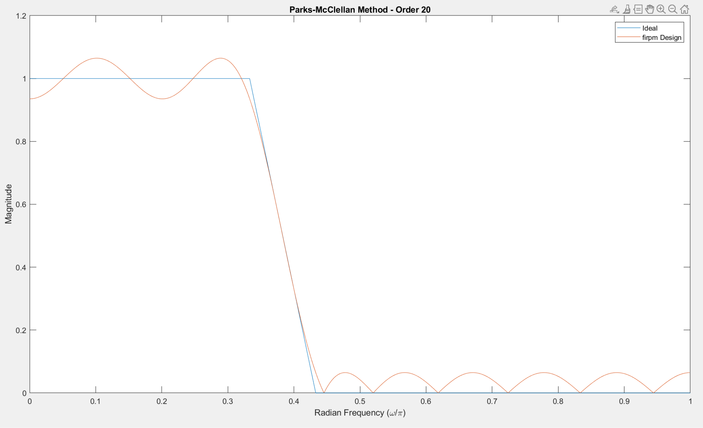

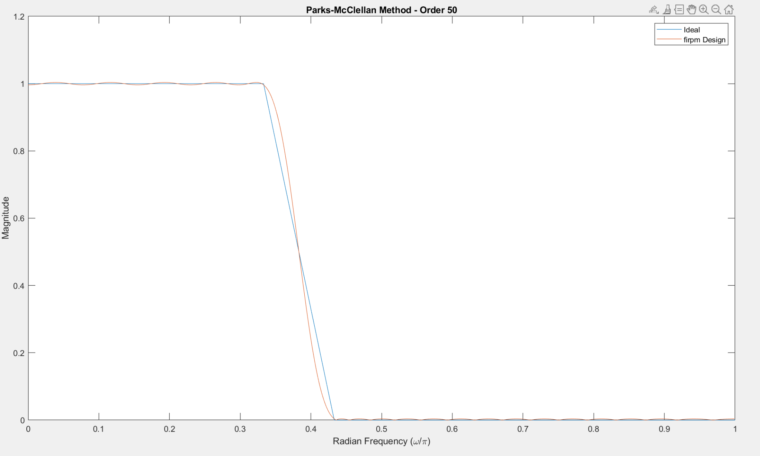

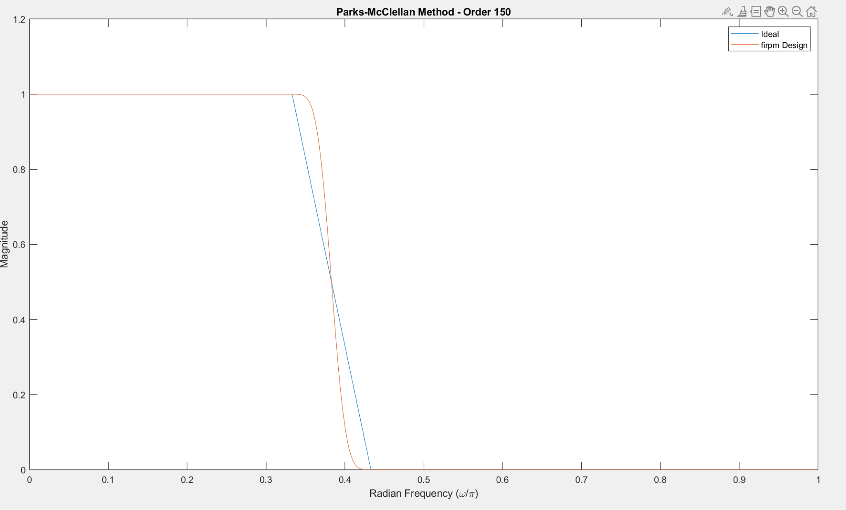

In the plots, we set the passband as 0 to 0.333pi(pi/3), and the stopband is 0.433pi to pi. We use built in function firpm to calculate H and generate the plots

B:

the passband is 0 to 0.333pi(pi/3), stopband is 0.533pi to pi

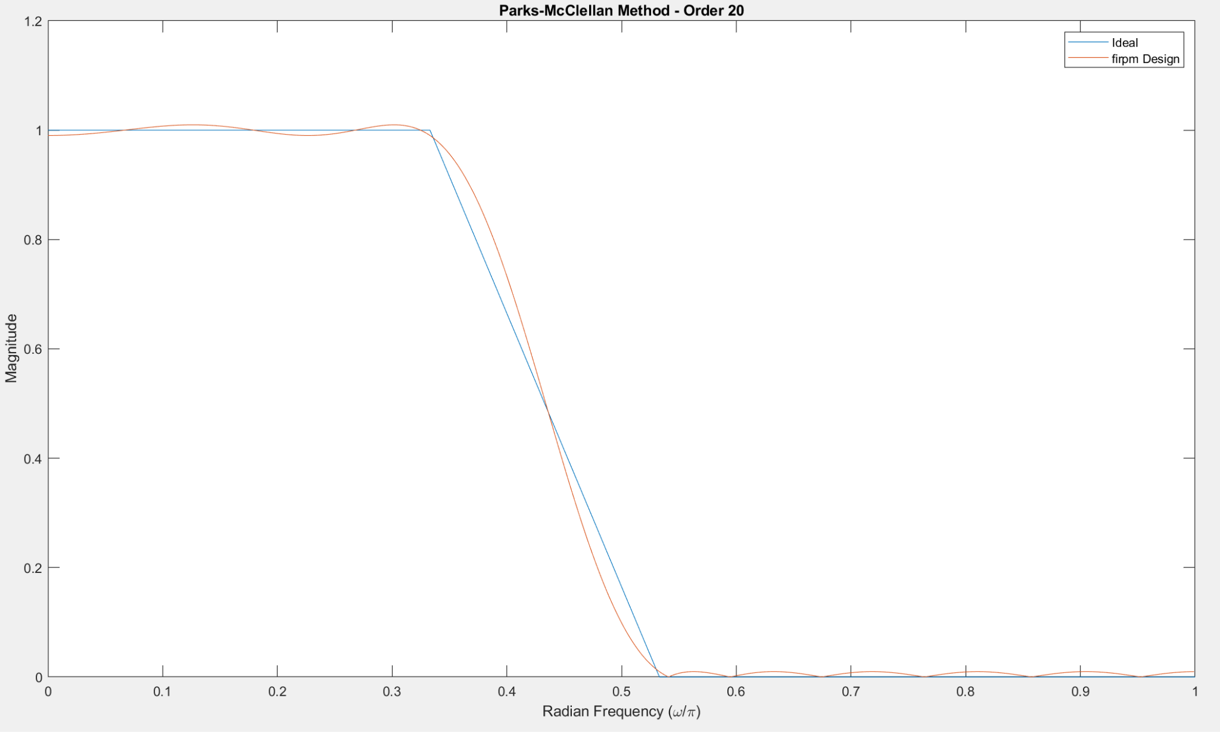

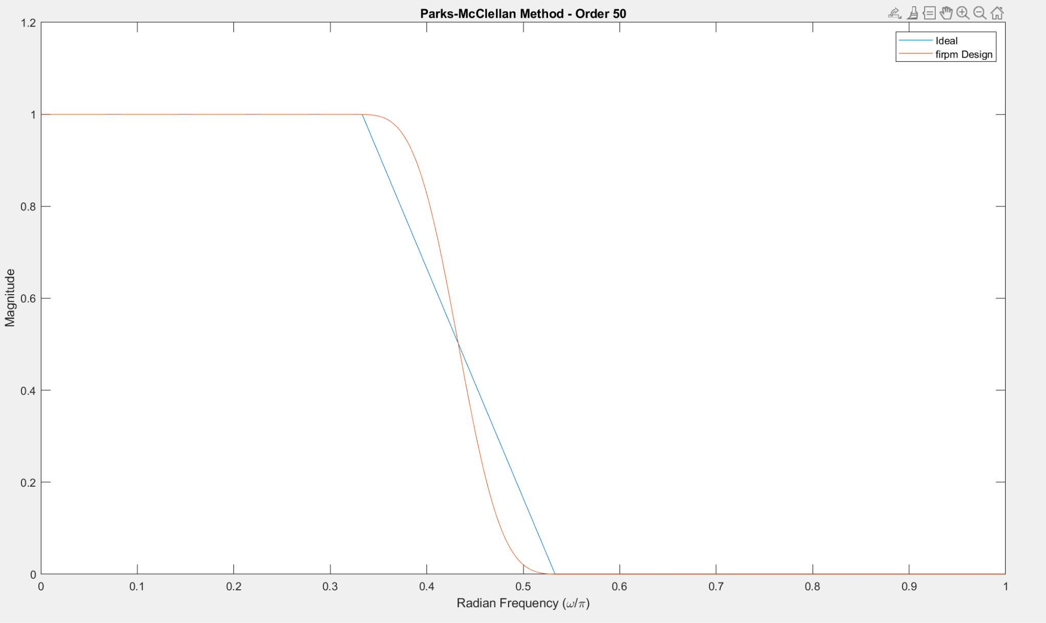

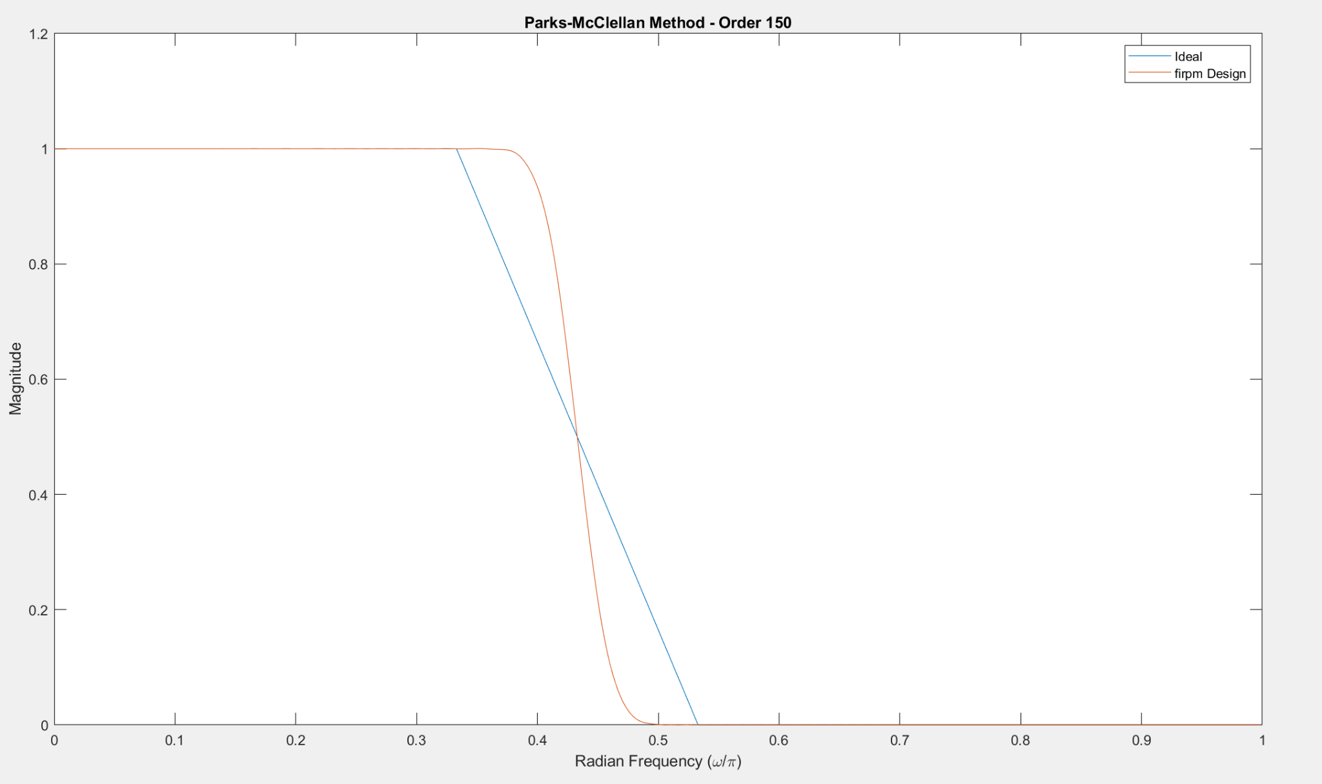

the passband is 0 to 0.333pi(pi/3), stopband is 0.336pi to pi

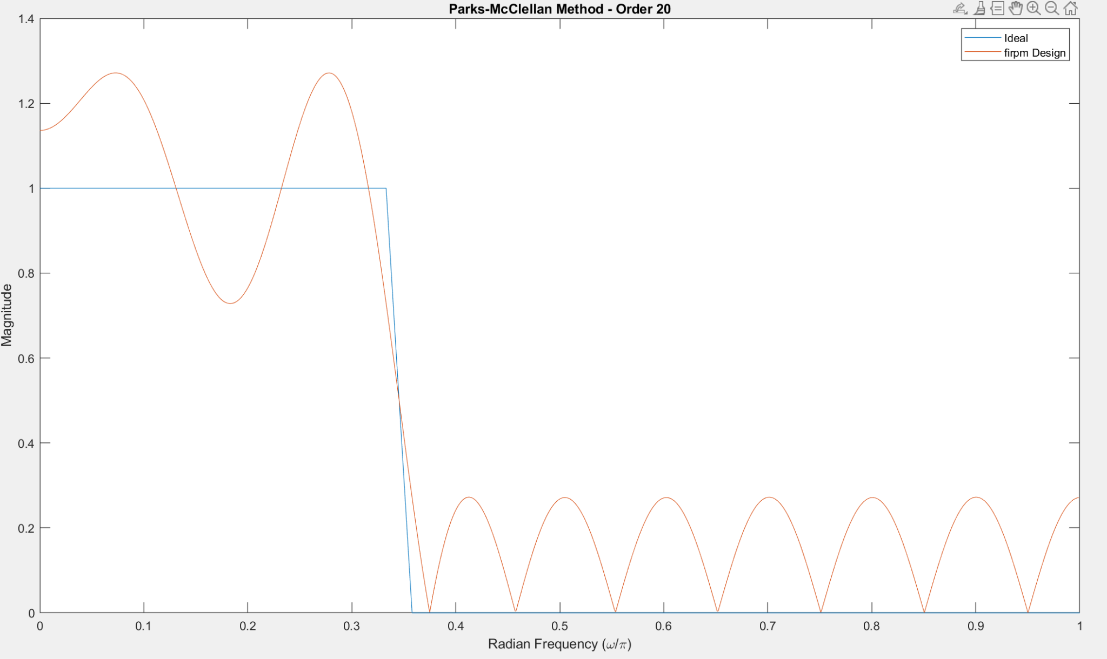

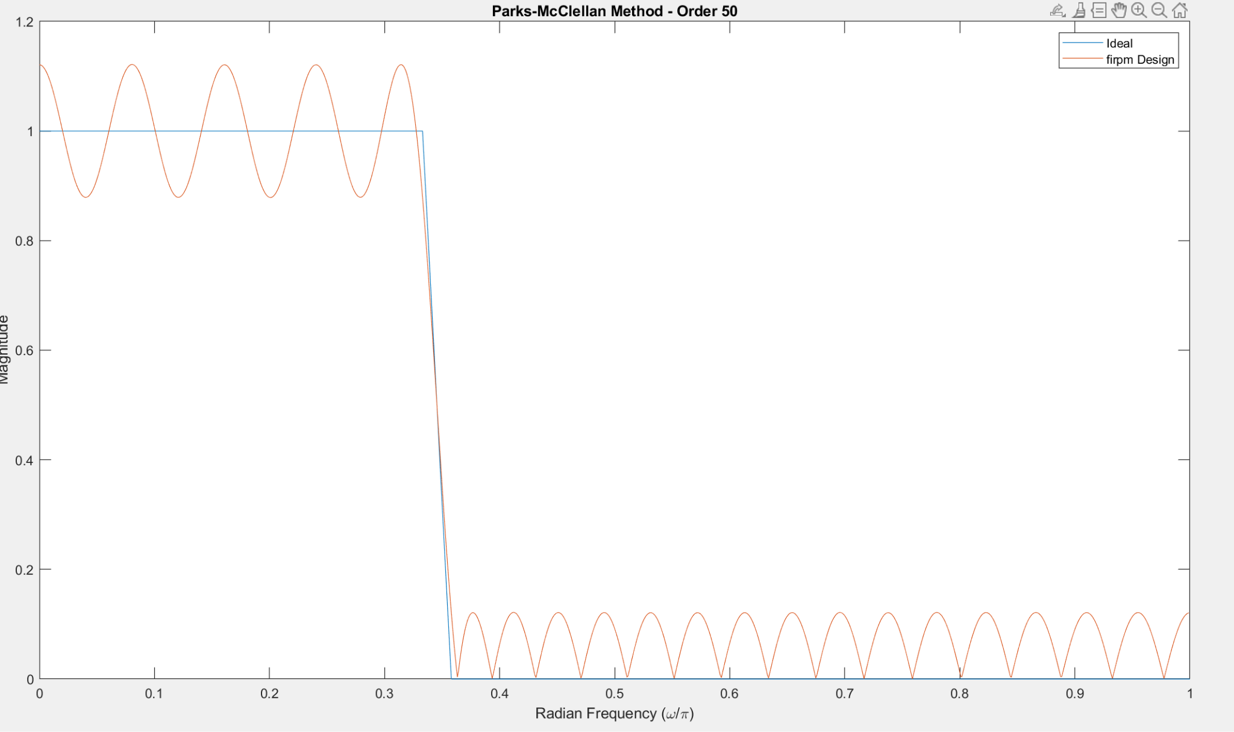

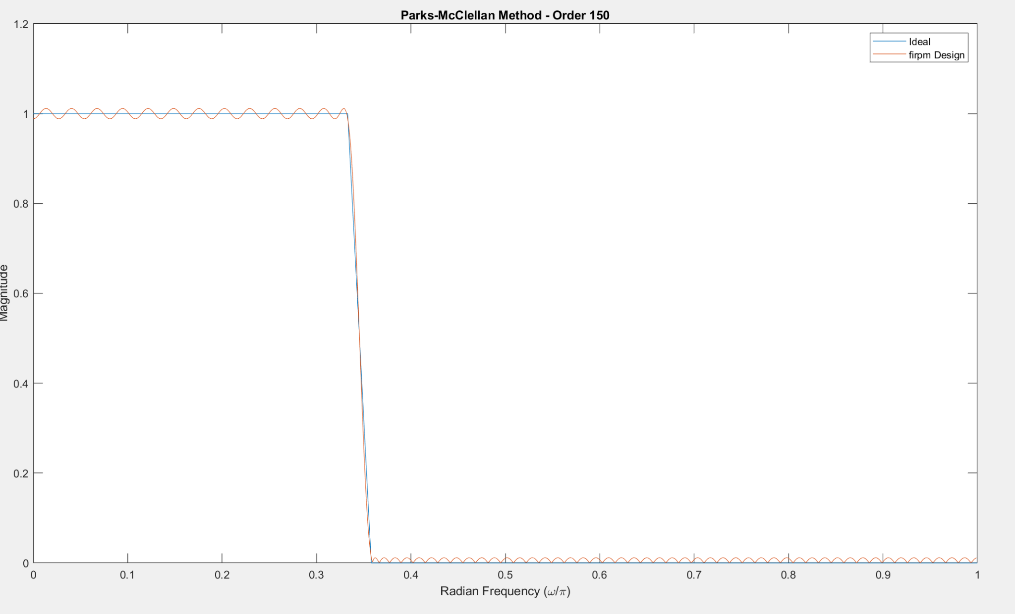

As we can see, we use a for loop to iterate a set of different Fc and the distance between the Fc and stopband. For example, the first plot of the fc is 0.333pi and the stopband distance from Fc is 0.1. And we found out, with smaller distance between Fc, the plots look more and more like an ideal lowpass filter with increasing N.

C:

Compared to the truncation method, we can find out that increasing the value of N will eliminate the Gibbs phenomenon. And if the difference of cut off and stopband starting frequency is small, the real response will be very similar to the ideal lowpass filter.

**3. FIR experiment on the TMS 320 DSP processor**

A and B:

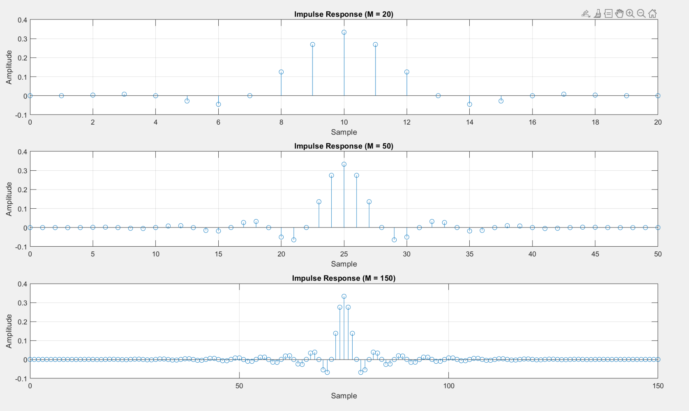

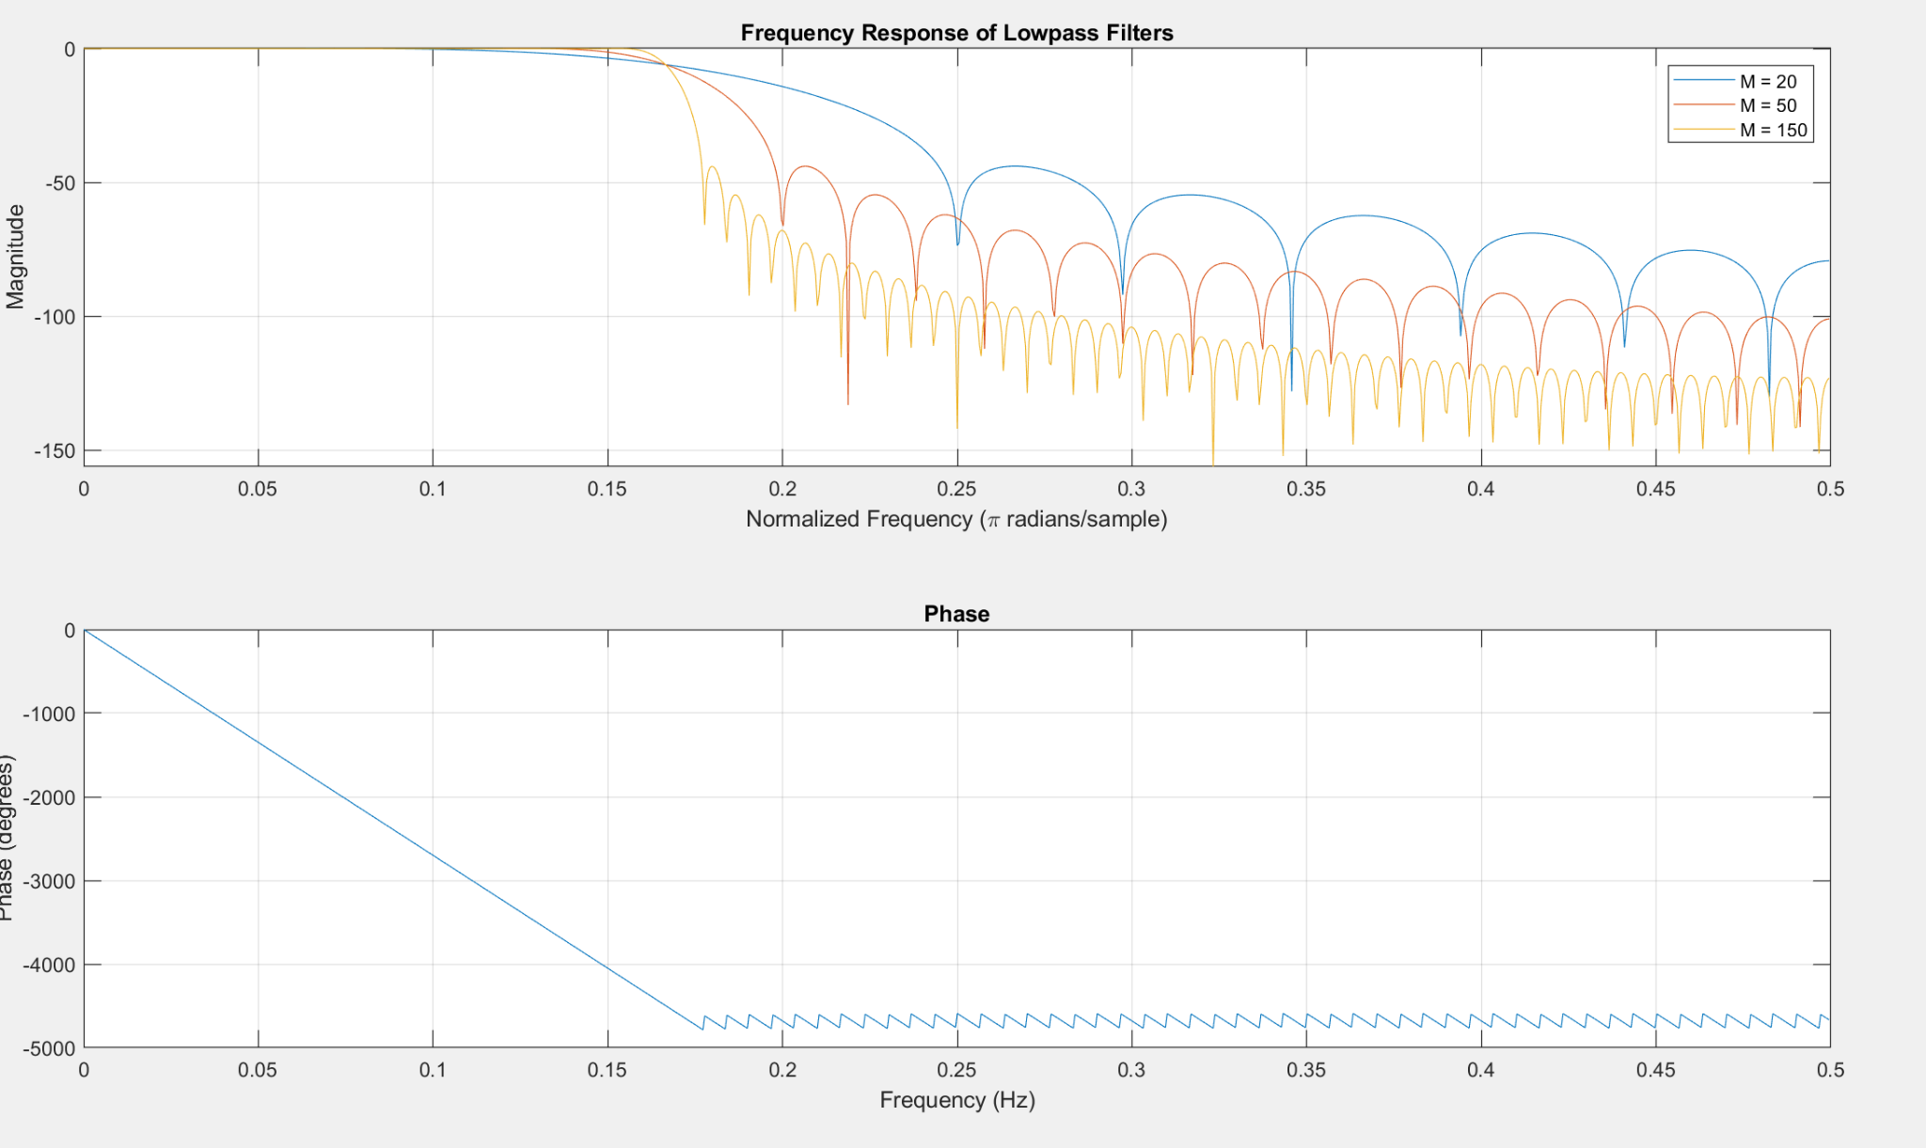

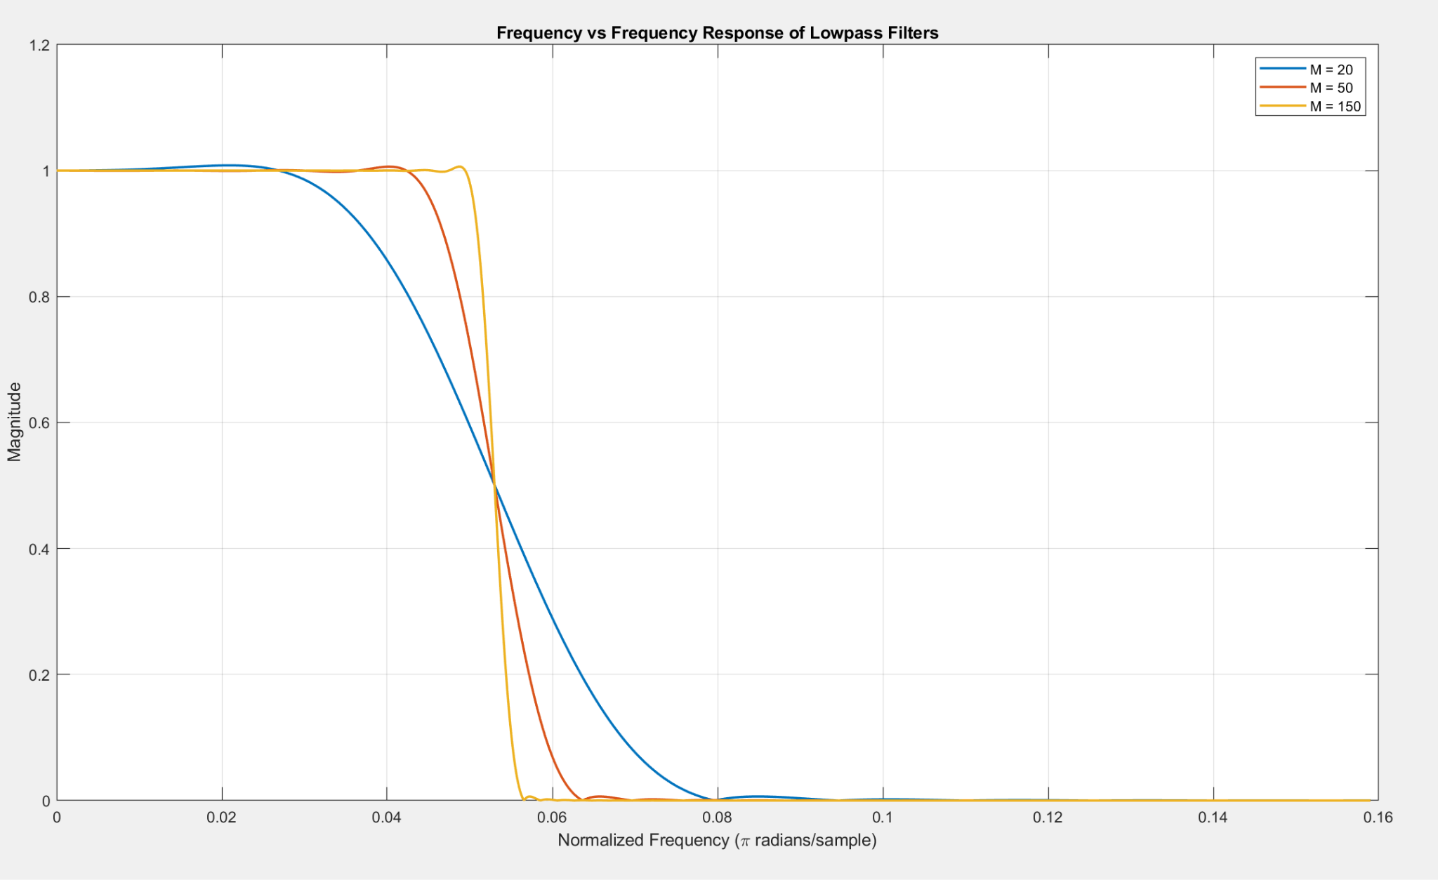

We use Matlab built in function fdatool to generate a passband filter and export the coefficient into a header file and overwrite the coefficient into the DSP and run the code one more time, with N set to 39, we have 40 coefficient. Below is the result when we run the matlab code and played the sound.

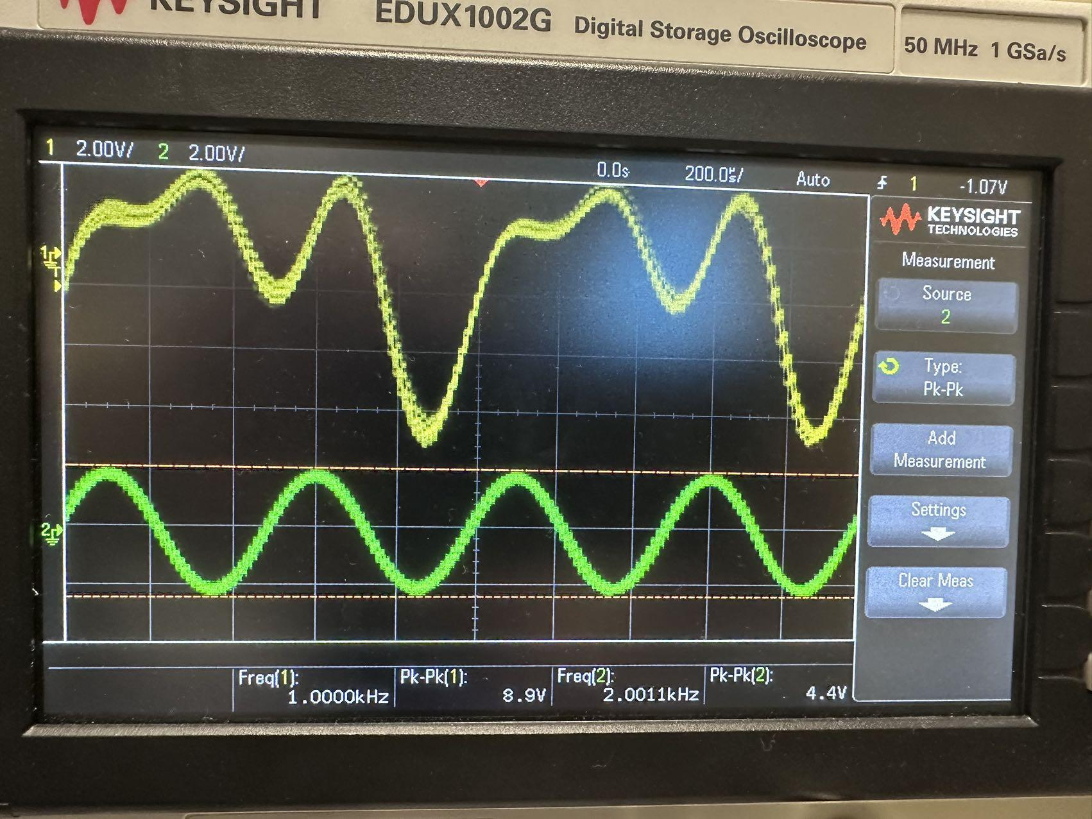

Channel 1 displays a repeating waveform with a frequency of 1 kHz, while Channel 2 shows a waveform with a frequency of 2 kHz, and the noise has been successfully filtered out. The two Pk-Pk values are quite different because channel 1 is mixed with three signals. All signals with frequency less than 1.5kHz or larger than 2.5 were filtered so the filtered result has the frequency 2 kHz which is the same as the x2.

C:

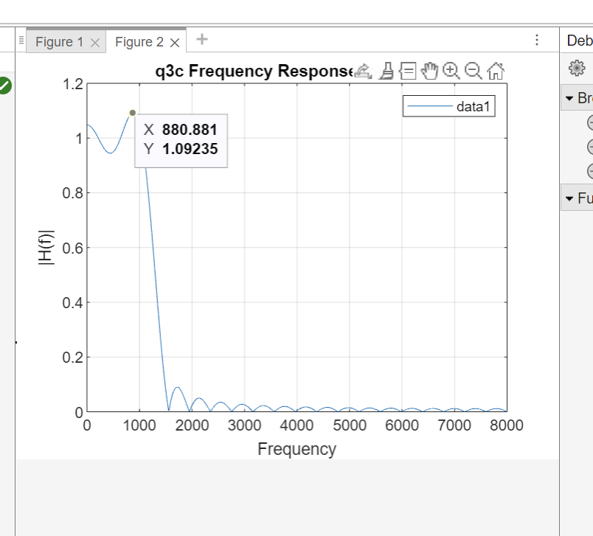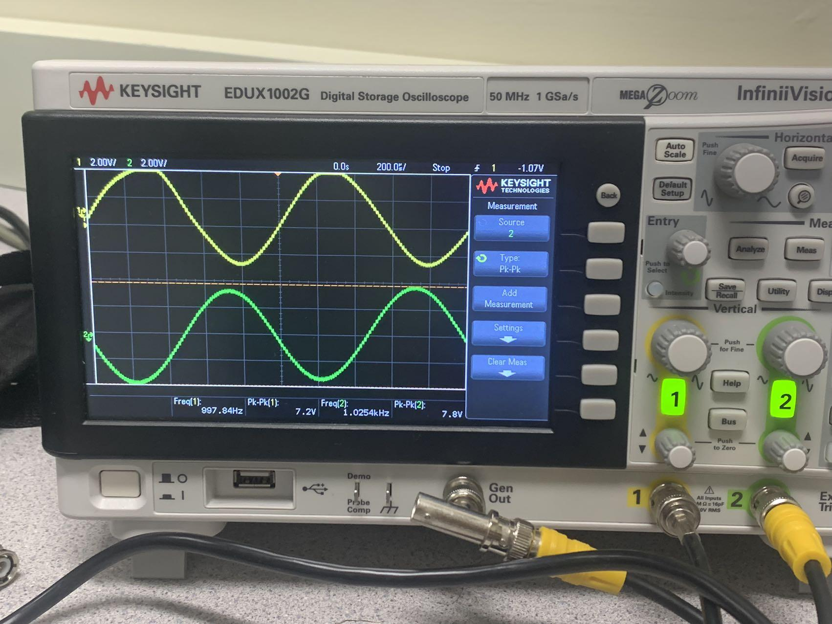

The pk-pk in channel 1 is 7.2V and the coefficient in the matlab figure is 1.092.

The pk-pk in channel 2 is 7.8V.  
 7.2V*1.092= 7.864V

The error between the experimental value and the theoretical value does not exceed 1%. The oscilloscope results fit our expectations well.